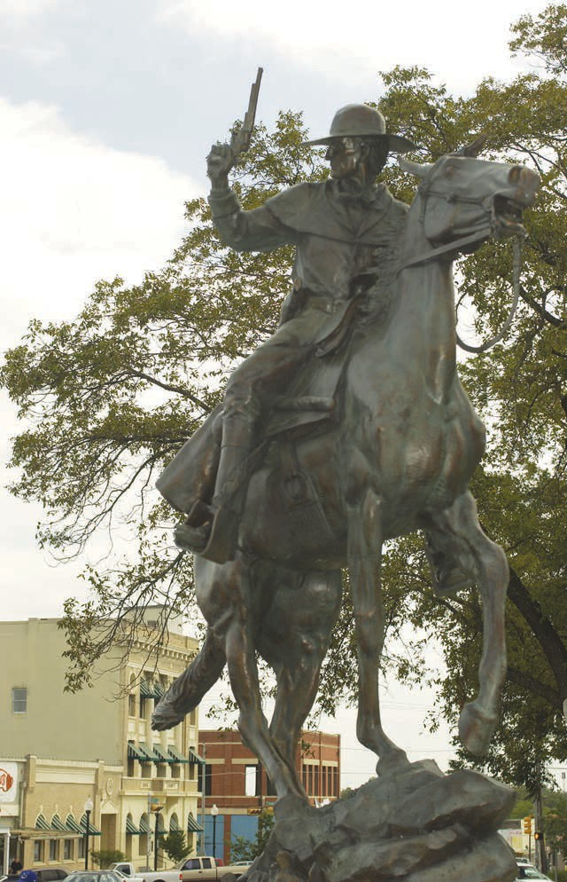

1

Emergency Management Association of Texas

Exhibitor Prospectus
13th Annual EMAT Leadership Symposium
February 23-25, 2020
San Marcos, TX

The Purpose of EMAT

The Emergency Management
Association of Texas (EMAT) is dedicated to the advancement of the field of emergency management both statewide and nationally. To that end, EMAT engages in an array of efforts to advance a statewide emergency management agenda and to promote the professional growth of the emergency management practitioner.

Symposium Attendee Profile

• Emergency Managers (city, county, state, federal)
• Homeland Security Professionals
• Contingency Planners
• Executive Officers
• Fire and Police Chiefs
• Police Chiefs
• Healthcare Disaster Professionals

• Independent School District

General Symposium Information

Symposium Date and Location
13th EMAT Annual Leadership
Symposium
February 23-26, 2020
Embassy Suites Hotel
San Marcos, TX

Hotel Accomodations
Embassy Suites Hotel San Marcos
1001 E. McCarty Lane
San Marcos, TX 78666
512-392-6450

Exhibitor Costs

• Standard 6 ft. Table-top Booth = $695
• 12 ft. Table-top Booth = $850

(Includes draped table, skirting, two chairs, one trash can, electricity and a listing in the Symposium program).
Each booth entitles the exhibiting company to (2) attendees, who are encouraged to attend the sessions and participate in meal/social functions.

Shipping Instructions

Due to limited storage space, exhibitor items should not arrive at the Embassy Suites more than 3 days prior to the Symposium date. Please ship to the hotel address above and include your name and company name. Exhibitors are responsible for return shipping.

Booth Space

Booths are assigned on a first-come, first-reserved basis.

EMAT Symposium Liability

EMAT assumes no liability whatsoever for loss or damage, through any cause, of goods, or other materials owned, rented, or leased by the exhibitor. The exhibitor shall indemnify EMAT against and hold it harmless for any complaints, suits, or liabilities resulting from the negligence of the exhibitor in connection with the exhibitor’’s use of the display space.

Cancellations

In the event that it is necessary to cancel your exhibit, no refunds will be made after February 1, 2020.

Questions

For questions, please contact the EMAT office: (512) 589-0675.

Exclusive Events

Exhibitor Schedule

Exhibitor Set-Up

Sunday, 2-23-20; 3:00 pm – 6:00 pm

Monday, 2-24-20; 7:00 am - 9:00 am

Exhibit Hours

Monday, 2-24-20; 8:00 am – 5:00 pm

Tuesday, 2-25-20; 8:00 am – 12:30 pm

Exhibitor Dismantle

Tuesday, 2-25-20; 12:30 pm – 3:30 pm
Exhibitors have the option to dismantle at 3:00 after the afternoon break.

EMAT uses several methods to encourage networking in the Exhibit Area including meals and door prizes. Dedicated events include:

Monday, 2-24-20
AM Break and PM Break

Tuesday, 2-25-20
AM Break and PM Break

There are several events during the EMAT Symposium that are available for sponsorship:

$350 Break Sponsor (4 available)
• Sign placed during break
• Conference attendee list

$500 Registration Sponsor
• Sign placed at registration
• Listing in the conference program
• Promotional material at entrance to event
• One (1) conference attendee registration
• Conference attendee list

$1000 Lunch Sponsor
• Sign at location
• Listing in the conference program
• Promotional material at entrance to event
• One (1) conference attendee registration
• Conference attendee list

$1000 Board of Director’s Reception Sponsor
• Sign at location
• Name in conference program next to the sponsored event
• 1/2 black & white page ad in the conference program
• Two (2) conference attendee registrations
• Conference attendee list

$1000 Member Appreciation Luncheon Sponsor
• Sign at location
• Name in conference program next to the sponsored event
• 1/2 black and white page ad in the conference program
• Two (2) conference attendee registrations
• Sponsor welcome message delivered to each conference guest upon hotel check-in
• Conference attendee list

Other Sponsorship Opportunities

• WiFi Sponsor - $350
• Lanyard Sponsor – includes your company name - $500
• Room Key Sponsor - $500

Door Prizes

Door prizes will be given away at the Board of Director’s Reception
If your company is interested in donating a Door Prize, please
contact Jim Coles at ematinfotx@gmail.com.

Advertisements and Logos

Ads and logos must be submitted in a JPEG, PDF or TIF format that is 300 DPI or better. Advertisements should be sent electronically to ematinfotx@gmail.com by January 25, 2020.
EMAT Symposium Application Embassy Suites Hotel
February 23-25, 2020 And San Marcos, Texas
Contract ANA

We invite you to participate in the EMAT 2020 Annual Leadership Symposium. Don’t miss this opportunity to interact with emergency managers, fire and police chiefs and representatives from Independent School Districts.

Contact the EMAT office: Address: 2502 Pace Bend Road South, Spicewood, TX 78669
Email: ematinfotx@gmail.com
www.emat-tx.org
Application deadline is February 1, 2020

Company Name_____________________________________________________________
Address __________________________________________________________________
City, State, Zip _____________________________________________________________
Phone __________________________________Fax______________________________
Contact Person ____________________________________________________________
Email Address_____________________________________________________________
Fee Schedule
Table Top Exhibits – Mon. 2-24-20 & Tues. 2-25-20
Monday 8:00 am – 5:00 pm
Tuesday 8:00 am – 12:30 pm
Exhibitor Set Up: Sun. 2-23-20, 3:00 pm – 6:00 pm
6’ Tabletop $ 695 _______
6’ Tabletop (non-profits) $ 45 _______
12’ Tabletop $ 850 _______
Total Number of Tabletop Exhibits is limited to 20 total.

Social Function Sponsorships Other Sponsorships
Breaks (4) $ 350 _______ WiFi Sponsor $ 350 _______
Registration $ 500 _______ Lanyard Sponsor $ 500 _______
Lunch $1,000 _______ Room Key Sponsor $ 500 _______
Board Reception $1,000 _______

Member Appreciation $1,000 _______
Luncheon

EMAT
2502 Pace Bend Road South
Spicewood, Texas 78669
512/589-0675-Phone
ematinfotx@gmail.com
www.emat-tx.org
EMAT Tax ID #76-0316601

Payment is due no later than February 1, 2020

Please Invoice
Check included in the amount of_________________________
MasterCard/Visa
Account#: ________________________________________

Exp. Date: ___________________ Sec. Code: _____________
Signature ____________________________________________________

Billing Address_________________________________________________

______________________________________________________________

_____________________________________________________________
EEMAT Annual Meeting Embassy Suites Hotel
March 1 – 4, 2015 San Marcos, Texas

We invite you to participate in the EMAT 2015 Annual Meeting. Don’t miss this opportunity to interact with emergency managers! Contact the EMAT office - Fax this form to 512/329-8943; send to 2525 Wallingwood Dr., Bldg 13A, Austin, TX 78746; email ematinfotx@gmail.com or call 1-877-306-3628. Application deadline is February 10, 2015.
Company Name___________________________________________________________
Address _________________________________________________________________
City, State, Zip ___________________________________________________________
Phone __________________________ Fax ____________________________________
Contact Person ___________________________________________________________
Email Address____________________________________________________________
Fee Schedule
Table Top Exhibits – Mon. 3-2-14 & Tues. 3-3-14 Exhibitor Set up:
Monday 8:00 am – 5:00 pm Sun. 3-1-15
Tuesday 8:00 am – 3:30 pm 12:00 pm – 6:00 pm
6’ Tabletop $ 975.00 __________
6’ Tabletop (non-profits) $ 25.00 __________
12’ Tabletop $1,250.00 __________
Any oversize display $1,475.00 __________
Social Functions
Breaks (4) $ 500.00 __________
Registration $1,000.00 __________
Lunch $1,200.00 __________
Welcome Mixer $1,200.00 __________
(Sunday night)
Appreciation Dinner $2,500.00 __________
(Tuesday night)

Payment is due no later than February 15, 2015

Please Invoice
Check included in the amount of_________________________
MasterCard/Visa
Account#: ________________________________________
Exp. Date: ___________________ Sec. Code: ____________

EMAT TAX ID # 76-0316601

