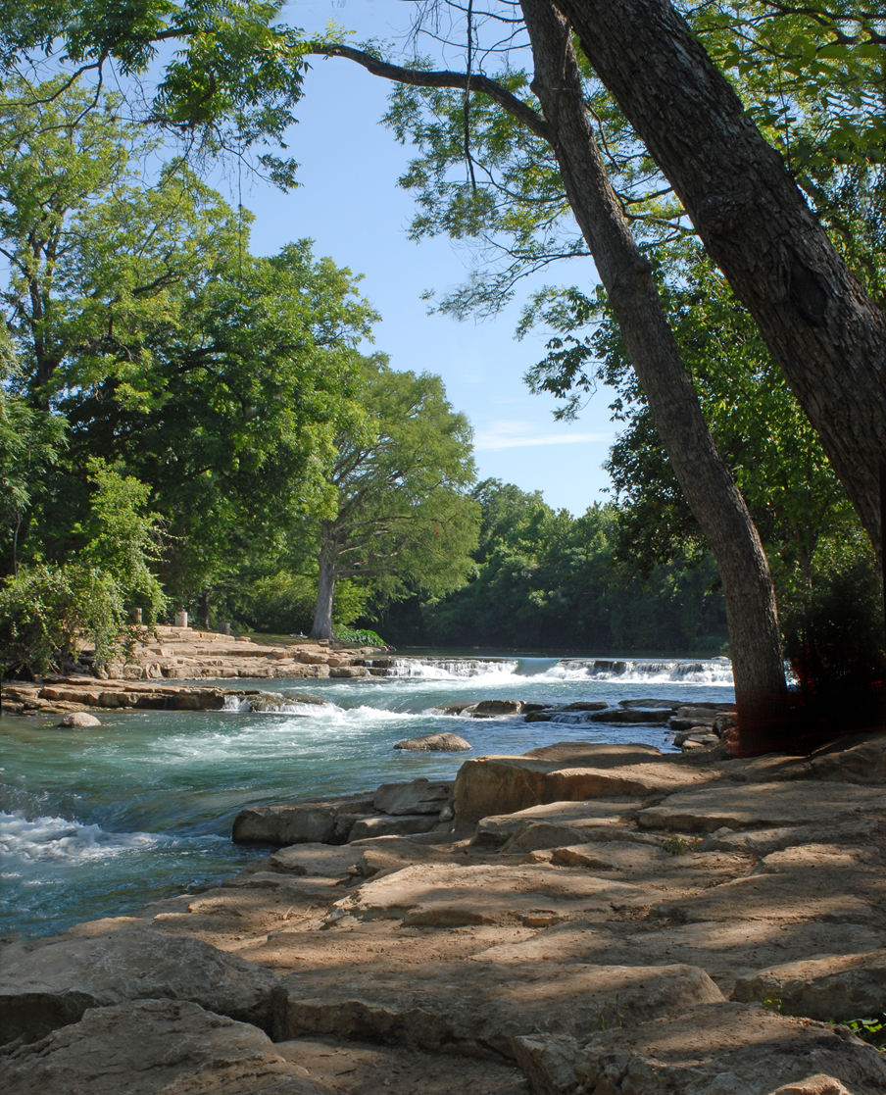

Emergency Management
Association of Texas

Speaker Guidance
13th Annual EMAT Symposium:
February 23-26, 2020
San Marcos, Texas

Speaker General Information

The Emergency Management Association of Texas (EMAT) is now accepting proposals for the 13th Annual EMAT Leadership Symposium.

Presentations that focus on current issues, lessons learned, creative/best practices, and participant interaction are strongly encouraged and will be given preference. Multiple submissions are welcome.

Speaker Submissions

The Presentation Submission form (page 4) must be filled out completely to be considered. All proposals must be submitted on or before November 1, 2019 by email to Jim Coles at ematinfotx@gmail.com. Early submissions are encouraged. Final approval of presentations will be made by the EMAT Symposium Planning Committee. Presenters will be notified of selection via email by November 20, 2019 to include the time, date and location of your presentation. This information will also be identified in the EMAT Symposium Program.

Speaker Contact Information

Please direct any speaker-related questions pertaining to the submission process to Jim Coles at ematinfotx@gmail.com.

Speaker Accommodations

Speakers are asked to make their own arrangements for accommodations. The 2020 EMAT Annual Leadership Symposium host hotel information follows:

Embassy Suites San Marcos – Hotel, Spa & Conference Center.
1001 E. McCarty Lane, San Marcos, Texas 78666.
Tel: 1-512-392-6450

EMAT Conference Liaison Committee
Patrice Reisen-Hicks, CEM, TEM – Symposium Planning Committee Chair
Hallie Frazee – Membership and Marketing Committee Chair
Chip Orton, TEM – EMAT Board/Communications Chair Jeff Choate, City of Mont Belvieu
Caroline Egan – Awards Committee Chair John Benzon, Harris County
Francisco Sanchez, TEM– EMAT President Matt Monea, American Public University
Laura Gehrig, TEM, Training Committee Chair Jarrett McLane, City of San Marcos
Dee Harrison, CEM, TEM, EMAT Board Manny Magos, TDEM
Justin Bunch, TEM, EMAT Board William Sederholm, TDEM
Rachel Ingle, TEM, EMAT Board Jennifer Henager, Bell County
Billy Ted Smith, TEM, EMAT Board Scott Collins, Aubrey ISD Jim Coles, EMAT Office Melissa Munguia, Nueces County Brad Britten, EMAT Board

Non-Commercial Nature of Sessions

The EMAT Annual Leadership Symposium provides a unique opportunity for open dialogue and creative exchange of ideas among participants. With this in mind, speakers and moderators must refrain from the use of brand names or specific product endorsements in their presentation. Under no circumstances is this platform to be used as a place for direct promotion of a speaker’s product, service or monetary self-interest.

Breakout Sessions

Breakout Sessions are 45-60 minutes in length. Room setup for the Breakout Sessions will be classroom style. Standard AV equipment will be provided in each room including a Laptop, Projector, Screen and Lavaliere microphone. If you have any special AV requirements, please complete the AV requirements section of the submission form and we will try to accommodate your request.

Handouts are the responsibility of the speaker. If you plan to supply handouts, please ensure that you bring an adequate amount for attendees. The suggested amount for a breakout session is 50.

Speaker Introductions

Speakers will be introduced at the beginning of their session by a Moderator representing the EMAT Conference Committee who will use the brief biography provided during the submission process. For Panel Presentations, EMAT Moderators will introduce the Lead Panelist. All other panelists will be introduced by the Lead Panelist prior to the start of the panel presentation.

Please arrive in your scheduled room 15 minutes prior to the start of your session to meet the Moderator and ensure audio visual needs are adequate.

Emergency – Prior to or During EMAT Symposium

If you are unable to present as the result of a last-minute emergency or you are deployed during the EMAT Symposium, please contact Jim Coles at ematinfotx@gmail.com or 512-589-0675.

Thank you for your interest in presenting at the 2020 EMAT Symposium. We look forward to seeing you in San Marcos!

Presentation Submission

All required fields designated with a * must be filled out prior to submitting a proposal for consideration. All proposals must be submitted on or before Friday, November 1, 2019.

Breakout sessions are limited to two presenters (complete page 5). For those submissions with more than two presenters, the presentation must be submitted as a panel discussion (complete page 6).

Please indicate which dates you are available to deliver your presentation. We will try to accommodate your schedule to the extent possible.

Presentation Title & Description
Title:
Description: (Please provide a brief description of the presentation within the space provided)

List 3 Presentation Objectives: (What will the audience learn?)
Audio Visual Requirements: (Standard setup includes Laptop, Projector, Screen, and Lavaliere Mic. Internet will not be available)

Preferred Presentation Date:

Any Date Monday, Feb. 24 Tuesday, Feb.25 Wednesday, Feb,26
AM AM AM
PM PM PM

Speaker Submissions
I / We give EMAT permission to record my/our presentation, to include my presentation materials in the symposium proceedings and to post my presentation on the EMAT web site.

Lead Presenter
Name:
Title:
Organization:
Website:
Address:
City: | State: | Zip:
Phone: | Cell Phone: | Fax:
Email:
Biography:

Co-Presenter
Name: (Please include certifications and credentials such as PhD, CEM, TEM, etc.)

Title:
Organization:
Website:
Address:
City: | State: | Zip:
Phone: | Cell Phone: | Fax:
Email:
Biography: (Please provide a brief description of the presenter’s current position, work history, and any degrees or certifications completed, or other related information within the space provided)

Panel Presentation
Name of Lead Panelist: (Please include certifications and credentials such as PhD, CEM, TEM, etc.)

Title:
Organization:
Website:
Address:
City: | State: | Zip:
Phone: | Cell Phone: | Fax:
Email:
Biography: (Please provide a brief description of the presenter’s current position, work history, and any degrees or certifications completed, or other related information within the space provided)

Panel Presentation
Panelist 2: (Please include certifications and credentials such as PhD, CEM, TEM, etc.)

Title:
Organization:
Email:
Panel Presentation
Panelist 3: (Please include certifications and credentials such as PhD, CEM, TEM, etc.)

Title:
Organization:
Email:
Panel Presentation
Panelist 4: (Please include certifications and credentials such as PhD, CEM, TEM, etc.)

Title:
Organization:
Email:

EMAT Conference Committee Use Only
Accepted Standby Declined
Session Date: | Session Time:
Room:
Moderator:
Notified: | Confirmed:

