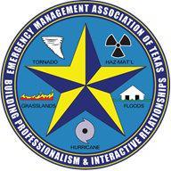

Emergency Management
Association of Texas

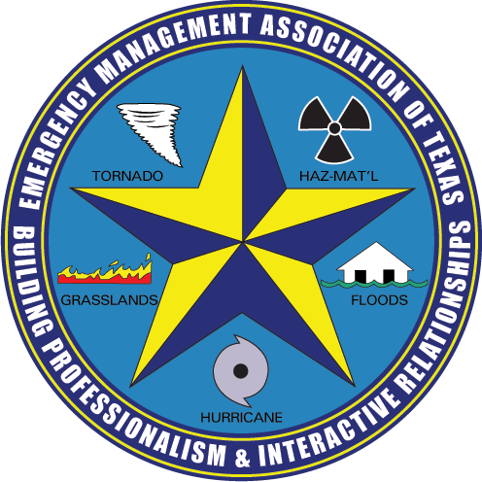

Exhibitor Prospectus
17th Annual EMAT Symposium
March 3-6, 2024
Embassy Suites Hotel, San Marcos, TX

The Emergency Management Association of Texas (EMAT) is dedicated to the advancement of the field of emergency management both statewide and nationally. To that end, EMAT engages in an array of efforts to advance a statewide emergency management agenda and to promote the professional growth of the emergency management practitioner.

Symposium General Information

Symposium Attendee Profile
- Emergency Managers (city, county, state, federal)
- Homeland Security Professionals
- Contingency Planners
- Executive Officers
- Fire and Police Chiefs
- Police Chiefs
- Healthcare Disaster Professionals
- Independent School District

Exhibitor Information

Exhibitor Hours
- Monday, 3-4-24; 8:00 am – 5:00 pm
- Tuesday, 3-5-24; 8:00 am – 5:00 pm
- Wednesday, 3-6-24; 8:00 am – 12:00 pm

Exhibitors/Sponsors
- Prominently featured Sponsor information on Symposium homepage and in dedicated areas.
- Exhibitor booths are strategically located in the Conference Center hallway by the educational sessions and break set up. In this the exhibit area, exhibitors can display details about their company and booth staff can highlight their products and services.
Built in Exhibitor Networking time so attendees can meet with exhibitors/sponsors either in a one-to-one or one-to-many setting.

Exhibitor Costs

Exhibitor | $895 – Only 20 Available
This allows for a 6 foot tabletop exhibit booth, company recognition each day during the symposium and two complimentary Symposium registrations. It also allows for two complimentary membership lunches on Monday, March 4, 2024. Exhibitors are allowed to attend the President and Board of Director’s Reception for $45 on Monday, March 4, 2024 at Hayes County Barbecue just a short distance from the Embassy Suites Hotel. Transportation provided.

Non-Profit Exhibitor | $75 – Only 3 Available
This allows for an exhibit booth, company recognition during the symposium and one complimentary Symposium registration.

Sponsorship Opportunities

President’s and Board of Director’s Reception - $2000 – 2 Available
This allows for a sponsorship of an off -site Barbecue and Drinks social event at Hays County Barbecue to recognize the EMAT President and Board of Directors.

Shuttle Bus Sponsor - $2000 – 1 Available The shuttle buses will take Symposium Attendees roundtrip from the Embassy Suites to the Hayes County Barbecue Restaurant. Signage and handouts are permitted on the shuttle buses and there are 2 complimentary dinners included with the sponsorship.

Luncheon Sponsor - $1500 - 2 Available
This allows for sponsorship of the Monday or Tuesday Luncheon for all Symposium Attendees. There are 3 complimentary lunches available for the luncheon sponsor.

Hays County Barbecue Dinner Ticket - $45 (Includes two free raffle tickets) – 5 Available

Break Sponsor - $350 – 4 Available
This allows for sponsorship of a morning or afternoon break on Monday or Tuesday. The program schedule has built in time for the breaks and interaction with the exhibitors.

Symposium Sponsor - $2000 – 1 Available
This allows for a sponsorship ad, company recognition each day during the symposium, two complimentary Symposium registrations, the Sunday evening Welcoming Reception, one break sponsorship and recognition for all tracks for the entire symposium.

Track Sponsor - $1000 – Choose 1 Track

Emergency Management Track
Leadership Track
Public and Mental Health Track
School Resiliency Track

This allows for company recognition each day during the symposium, two complimentary Symposium registrations, one break sponsorship, recognition for a track for the entire symposium.

President’s Reception ticket - $45 – 5 Available
This allows for a sponsorship attendance of an off -site Barbecue and Drinks social event at Hays County Barbecue to recognize the EMAT President and Board of Directors.

Advertisements/Logos
Ads and logos must be submitted in a JPEG, PNG, MP4 format that is 300 DPI or better. Files should be sent electronically to ematinfotx@gmail.com by January 20, 2024.

FAQ

- How do I get my Exhibit Booth Number?
There are no Booth Numbers since the total number of booths is capped at 20.
- What is included with my Exhibit Booth? A 6 foot table, two chairs, electricity, internet and a small trash can.
- When do I set up my Exhibit Booth? From 2:00 – 4:00 pm on Sunday, March 3, 2024.
- Do I need to check in at the registration desk? Yes, please check in for the location of your booth and any name badges.
- Should I bring a door prize to be raffled off at the Monday luncheon? Yes Please, symposium attendees are more likely to visit your exhibit booth when a door prize is available.
- How many Exhibit Booth staff are allowed to attend? Two
- Can Exhibit Booth Staff attend the Monday luncheon? Yes, two.
- Can Exhibit Booth Staff attend the President and Board of Director’s social event at Hays County Barbecue? Yes, but there is a charge of $45 per attendee. This amount is a break even cost. You will need a ticket to attend.
- Will Name badges be provided and what is the deadline to submit the names of the Exhibit Booth Staff? Name Badges are provided only if the names are sent to EMAT by Friday, January 23, 2024. It is not a requirement to use an EMAT name badge – some companies prefer to use their company name badge.
10. Should I make hotel reservations at the Embassy Suites and is there a Group Discount Code for EMAT? Yes, the Group Discount Code is ema. It is just three letters instead of four as mandated by the hotel. You are helping EMAT by using the Room Block.
11. What is the deadline for a hotel reservation at the Embassy Suites? The deadline for a hotel room reservation is January 15, 2024.

Have any other questions? – Please email your questions to ematinfotx@gmail.com

THANK YOU!

EMAT SYMPOSIUM CANCELLATION POLICY

If a Symposium Registration is cancelled, only a full refund is given if the cancellation is over 90 days prior to the event. Consideration of a full refund at any time prior to the event due to an emergency or medical issue will be decided by the Symposium Planning Committee. Less than 90 days has the following refund amounts less a cancellation fee.

-Before 90 days - Full Refund
-90 days prior - Refund less 10%
-60 days -prior – Refund less 25%
-30 days prior – Refund less 50%
-Less than 30 days – No Refund
APPLICATION DUE: January 20, 2024
We invite you to participate in the EMAT 2024 Annual Symposium. Do not miss this opportunity to interact with emergency managers, fire and police chiefs and representatives from Independent School Districts.

Application & Contract
Contact Person:
Title:
Company Name:
Website:
Address:
City: | State: | Zip:
Phone:
Email:
Fee Schedule

Exhibitor Sponsor ($895) Luncheon Sponsor ($1500) Non-Profit Exhibit ($75)

Symposium Sponsor ($2000) Track Sponsor ($1000) Break Sponsor -$350

President and Board Reception - $2000 Shuttle Bus Sponsor - $2000

Sponsor Ticket for President’s reception - $45

County County
Payment Information
Please Invoice
Check Included in the amount of:
MasterCard/Visa:
Card Number:
Expiration (MM/YY): | CVV:
Billing Address:
City: | State: | Zip:

EMAT
2502 Pace Bend Road South, Spicewood, Texas 78669
512-589-0675
ematinfotx@gmail.com
www.emat-tx.org
EMAT Tax ID #76-0316601

